**Jenkins**

Stages of Pipeline:

maven lifecycle:

Build is failing:

Jenkins back-up to s3:

Java_path:

declarative Pipeline:

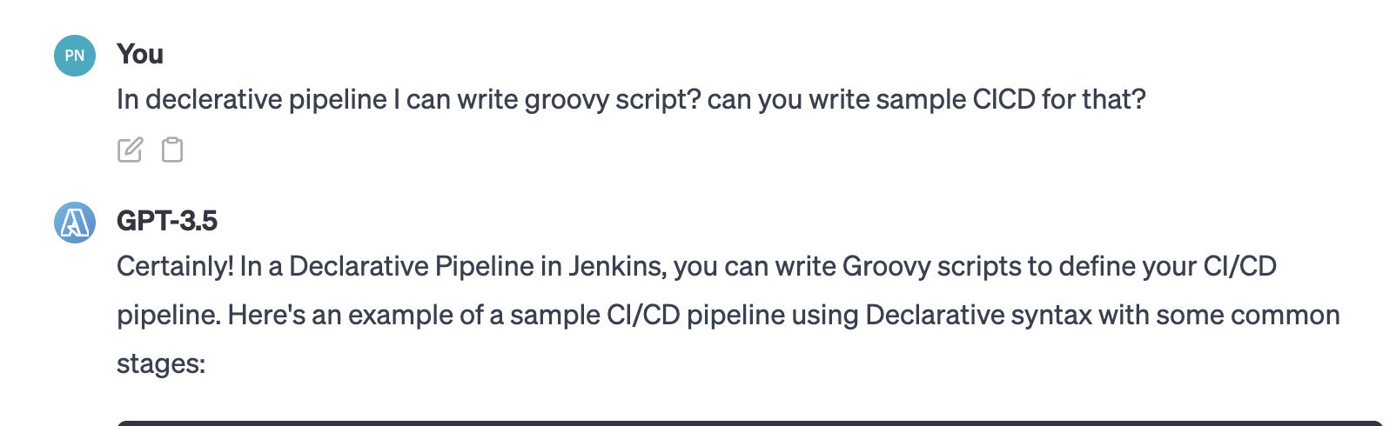

CI/CD step by step:

Approval:

Master and slave nodes:

Helm:

